**CST2103 Lab 03 Submission Form**

**Name Student 1: Carlos Timoteo Student Number :** 040905599

**Name Student 2: Samanda Poovin Student Number :** 040884056

**Name Student 3: Ahmad Al-Mansour Student Number :** 040905306

1. **Task 5 Questions**
   1. What is the layer 7 protocol? Hypertext Transfer Protocol
   2. What is the Layer 4 protocol? Transmission Control Protocol
   3. What is the Layer 3 protocol? Internet Protocol v4
   4. What is the Layer 2 protocol? Ethernet II
   5. What is the frame’s destination MAC address?

00:0c:29:60:08:8d

* + 1. This destination’s MAC address belongs to which device? The server laptop
  1. What is the destination IP address?

192.168.1.124

* + 1. This IP address belongs to which device? My laptop server.
  1. What is the destination port? 8088 TCP port.

1. **Task 5 Step 5.2**

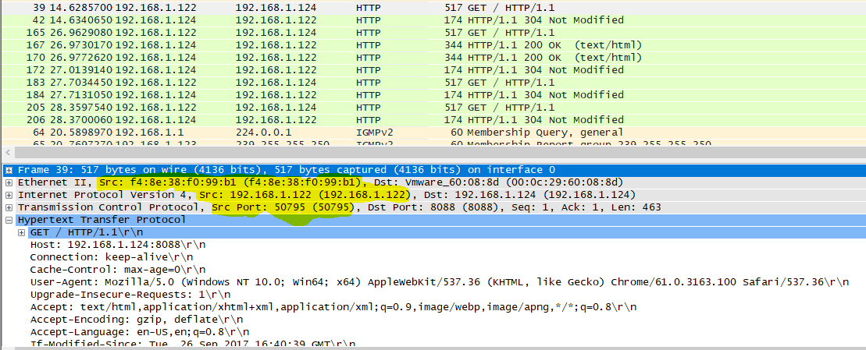

1. Task 8 Questions
   1. What is the frame’s destination MAC address?

B4:75:0E:B4:8A:4D

* + 1. This destination’s MAC address belongs to which device?

To the router gateway.

* + 1. Explain why?

Since we are at different networks, the ethernet frame contains the destination mac address of the router gateway. The router gateway is in charge of transmission of the frames outside the local network.

* 1. What is the destination IP address?

10.50.11.160

* + 1. This IP address belongs to which device?

To the remote web server.

1. **Task 8 Step 8.2**

